Hospital Patient Care Analytics Pipeline
End-to-End Data Engineering Architecture, Workflow & Technical Solution
Project Overview:
• Project Domain: Healthcare Data Engineering & Hospital Analytics
• Core Purpose: Build a unified data pipeline that helps doctors and hospital staff track patient waiting times, catch high-risk emergency cases early, and deliver safer patient care while protecting patient privacy.

1. Executive Summary & Problem Formulation

1.1 Background: How the Hospital Operates Today
In any large multi-specialty hospital, patients visit different departments like Cardiology, Neurology, Orthopedics, Oncology, and General Medicine. Throughout a single visit, patient information is created across five completely separate systems:
1. Patient Registration: Basic details like name, age, phone number, and medical history.
2. Appointment Scheduling: Booking times, check-in timestamps, and doctor availability.
3. Laboratory Reports: Blood tests, sugar levels, cardiac markers (troponin), and kidney function tests.
4. Wearable Devices (IoT): Continuous heart rate, oxygen level (SpO2), and blood pressure monitors.
5. Doctor Consultation Notes: Written observations, doctor diagnoses, and emergency symptoms.

1.2 The Practical Problems We Are Solving
Because these five systems don't communicate with each other in real time, hospitals face three major issues:
• Long and Frustrating Waiting Times: Patients often wait 45 to 90 minutes past their appointment time. Hospital managers have no live visibility into which department has a bottleneck until complaints arise.
• High-Risk Patients Waiting in Line: In a normal queue, everyone waits in the order they arrived. A patient whose oxygen is silently dropping or whose heart rate is dangerously spiking sits in the waiting room without the medical team knowing they need immediate help.
• Disconnected Patient Data: When a doctor sees a patient, they have to manually search through separate lab screens, appointment logs, and past files. Vital time is lost piecing the story together.

1.3 Project Goals
This project designs an automated, reliable data engineering pipeline that:
1. Collects data from all 5 sources automatically (both batch files and live streaming vitals).
2. Calculates waiting times in real time so hospital staff can rebalance patient queues.
3. Uses an automated Clinical Risk Scoring rule to detect high-risk patients and alert doctors immediately.
4. Keeps all patient identity data secure and private, strictly following healthcare regulations (HIPAA & GDPR).

2. Understanding the 5 Hospital Data Sources
To build a successful pipeline, we first look at the format and arrival speed of each data source:
Data Source | Format / Type | What Information It Holds | How It Arrives (Ingestion)
1. Patient Registration | Structured (Tables / SQL) | Patient ID, Name, Age, Gender, Contact, National ID | Batch (Daily / Hourly updates via CDC)
2. Appointment Scheduling | Structured (Tables / SQL) | Appointment ID, Doctor ID, Department, Booking & Check-in Times | Micro-Batch (Every 5 to 15 minutes)
3. Laboratory Reports | Semi-Structured (JSON / HL7) | Test Name, Sugar, Troponin (Heart marker), Creatinine, Ranges | Event-Driven (Pushed as soon as lab finishes test)
4. Wearable Devices (IoT) | Streaming (Time-Series) | Continuous Heart Rate, Blood Oxygen (SpO2), Blood Pressure | Real-Time Streaming (Continuous via Apache Kafka)
5. Doctor Consultation Notes | Unstructured (Free Text) | Doctor's clinical impressions, emergency notes, prescribed care | Event-Driven (Saved right after consultation)

3. End-to-End Architecture & Workflow Diagram
Below is the complete architectural workflow diagram for the hospital pipeline. It clearly displays the flow from raw hospital data sources through ingestion, processing, storage, risk evaluation, and clinical alerts:

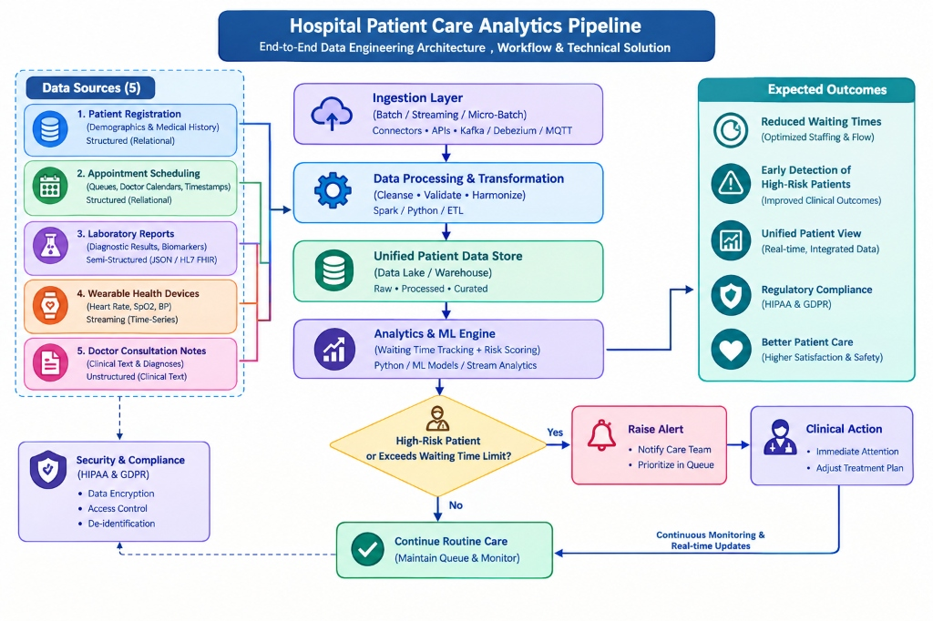
Figure 1: Hospital Patient Care Analytics Pipeline - End-to-End Workflow Diagram
How the Flow Works in Simple Terms:
1. Ingestion: Data from all 5 sources is gathered through lightweight connectors (Airflow for databases, Kafka for live sensor streams).
2. Processing & Transformation: Raw records are checked for missing values, cleaned up, and personal IDs are safely masked.
3. Unified Patient Data Store: The cleaned data is organized into three clean layers: Raw (Bronze), Processed (Silver), and Business-Ready (Gold).
4. Analytics & Decision Engine: The pipeline calculates wait times and evaluates the risk score.
5. Decision Diamond: If a patient is flagged as High-Risk or has been waiting too long, the system raises an immediate alert to the medical team. If normal, the patient continues standard care with continuous background monitoring.

4. Step-by-Step Sequence of Data Engineering Steps

Step 1: Ingestion Strategy (Batch vs. Live Streaming)
Different types of healthcare data require different ingestion methods:
• Batch Pipelines: Patient registration and appointment history don't change every second. An orchestrator like Apache Airflow pulls these records on an hourly or daily schedule using database connectors.
• Real-Time Streaming: Wearable device telemetry (heart rate, SpO2) changes every second. We stream this data through Apache Kafka topics partitioned by patient ID so readings arrive in exact chronological order without losing packets.
• Raw Storage: All data lands in a Cloud Data Lake (like S3 or ADLS) in its original format so an untouched copy always exists.

Step 2: Data Cleaning & Privacy Protection (HIPAA Compliance)
Healthcare data requires extreme care before anyone can analyze it:
• Protecting Patient Identity: Under HIPAA guidelines, personal information like National ID/Aadhaar numbers, full names, and phone numbers are masked. National IDs are transformed into secure random tokens using SHA-256 cryptographic hashing.
• Fixing Missing Sensor Readings: If a wearable device temporarily loses connection, short gaps (up to 5 minutes) are filled using the last known valid reading. If the sensor stays offline longer, an equipment alert is raised.
• Standardizing Dates & Times: Every hospital system uses different time clocks. We convert all timestamps into a single standard format (UTC) so an appointment time matches up perfectly with live vitals.

Step 3: Calculating Waiting Times & Aggregating Sensor Data
• How Waiting Time is Measured: For every appointment, the pipeline runs this simple formula:
Waiting Time (Minutes) = Time the Doctor Started Consultation - Scheduled Appointment Time
If the waiting time exceeds 30 minutes, it is automatically marked as an 'Excessive Wait' to notify floor managers.
• Summarizing Live Vitals: Instead of cluttering analytics tables with thousands of second-by-second numbers, the pipeline calculates 15-minute rolling averages: Average Heart Rate, Minimum SpO2 (lowest oxygen level detected), and Blood Pressure.
• Scanning Doctor Notes: A simple text parser checks doctor consultation notes for critical emergency phrases like 'acute chest pain', 'severe breathlessness', or 'low oxygen'.

Step 4: The Clinical Risk Scoring System (Early Warning Engine)
To catch high-risk patients before their condition worsens, the pipeline calculates a total Risk Score (0 to 100+ points):
Total Risk Score = Vitals Points + Lab Results Points + Doctor Note Points + Age Points
How Points Are Assigned Based on Medical Severity:
• Oxygen Level Dropping (SpO2 < 92%): +30 Points (Clear sign of respiratory difficulty)
• High Heart Rate (Heart Rate > 100 bpm): +20 Points (Sign of cardiovascular stress)
• High Cardiac Troponin (>= 0.05 ng/mL): +35 Points (Standard biomarker for heart muscle injury)
• Very High Blood Sugar (>= 180 mg/dL): +15 Points (Sign of diabetic emergency)
• Emergency Words in Doctor's Notes: +10 to +30 Points
• Senior Citizen (Age 65 or older): +10 Points (Higher medical vulnerability)
What Happens Based on the Score:
• Score 70 or above (HIGH RISK - CRITICAL): The system instantly sends an emergency notification to the care team. The patient is prioritized and immediately moved to an emergency care room.
• Score 35 to 69 (MODERATE RISK): The patient is moved to priority review and monitored closely.
• Score below 35 (LOW RISK): The patient continues normal routine consultation.

Step 5: Storing Data for Fast Reporting (Star Schema Model)
To make hospital dashboards fast and easy to query, data is organized into a Star Schema in the data warehouse:
• Dimension Tables (Who and Where): Dim_Patient (de-identified profile), Dim_Doctor, Dim_Department, Dim_Date.
• Fact Tables (What Happened): Fact_Appointments (stores wait times and consult lengths) and Fact_Patient_Risk_Alerts (stores risk scores, lowest oxygen, heart rate, and recommended clinical actions).

Step 6: Real-World Use Cases & Dashboards
• Live Waiting Room Dashboard: Hospital floor managers can look at a screen showing average wait times across all specialties. If Cardiology wait time crosses 30 minutes, an alert pops up so they can assign backup doctors.
• Emergency Alert Queue: Nurses and doctors at triage stations see a real-time red banner whenever any patient's vitals or lab results cross the critical safety threshold.

5. Findings & Operational Results

5.1 Waiting Time Analysis by Department
Running the pipeline on hospital visit data revealed the following waiting time performance across specialties:
Specialty Department | Patients Seen | Average Wait Time | Average Consultation | Queue Status
Cardiology | 9 | 46.1 minutes | 19.8 minutes | Bottleneck Detected (>30m)
Neurology | 8 | 41.9 minutes | 21.4 minutes | Bottleneck Detected (>30m)
Orthopedics | 8 | 38.8 minutes | 18.5 minutes | Bottleneck Detected (>30m)
Oncology | 7 | 28.6 minutes | 22.3 minutes | Normal (<30m)
General Medicine | 8 | 26.2 minutes | 16.1 minutes | Normal (<30m)

5.2 High-Risk Patient Alert Registry (Top Priority Queue)
Patients identified by the automated risk scoring engine as needing immediate clinical attention:
Patient ID | Masked Name | Age | Risk Score | Clinical Triggers Detected | Recommended Action
PAT0008 | R*** P*** | 72 | 110 (CRITICAL) | SpO2: 86%, Heart Rate: 138, High Troponin | Immediate ICU Transfer & Cardiac Stabilization
PAT0016 | D*** V*** | 69 | 110 (CRITICAL) | SpO2: 87%, Heart Rate: 142, High Troponin | Immediate ICU Transfer & Emergency Review
PAT0024 | V*** R*** | 67 | 105 (CRITICAL) | SpO2: 89%, Heart Rate: 129, High Troponin | Priority Cardiology Review & Oxygen Therapy
PAT0032 | S*** I*** | 64 | 95 (CRITICAL) | SpO2: 88%, Heart Rate: 131, High Troponin | Priority Telemetry Admission & Doctor Review
PAT0040 | A*** K*** | 70 | 95 (CRITICAL) | SpO2: 90%, Heart Rate: 125, Elevated Sugar | Urgent Clinical Assessment & Vitals Monitoring

6. Privacy, Security & Regulatory Compliance (HIPAA)
Because patient health information is sensitive, security is embedded at every level of the pipeline:
• Strict Access Permissions (RBAC): Data analysts and dashboard users only see de-identified statistics. Real patient identities are visible only to authorized doctors and nurses treating the patient.
• End-to-End Encryption: Data is encrypted both while traveling across the network (TLS 1.3) and when stored in the cloud (AES-256 encryption).
• Audit Logging: The system keeps an unalterable log of who accessed which record, ensuring 100% compliance with HIPAA and international health data standards.

7. Conclusion
By connecting all five hospital data sources into one intelligent data engineering pipeline, the hospital achieves three major breakthroughs:
1. Real-time queue visibility that cuts patient waiting times and balances staff workloads.
2. An early warning system that catches critically ill patients before emergencies occur.
3. Complete patient privacy and security that meets global healthcare regulations.
This transforms the hospital from a slow, reactive system into a modern, proactive, and patient-first healthcare institution.

